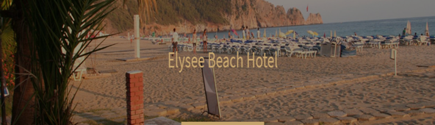

Located on the right sight of the Cleopatra Beach, with its 60 Rooms and 120 Beds, situated within walking distance of Alanya’s places of interest, Elysee Beach Hotel has been serving tourists since 1996. The Rooms are nicely furnished and well equipped with Air-conditioner, TV, Mini Bar ,Music (over the TV), Hair Dryer and safe box. Apart from Accommodation, Elysee Beach Hotel offers Restaurant Pool, Sauna, Massage Room and Turkish Bath for the use of its guests.

**Location**: Situated west cost of Alanya.

**Directions**: Airport 124Km/85 minutes by car. City Center 800 m/10 minutes by walk.

**Points of interest**: Alanya Castle and city wall, Damlatas Cave, Dim Cave, Bazaar

**Guest Room Amenities**:

* Individually controlled air conditioning
* Private bath and shower.
* Radio (over the TV)
* Remote control satellite TV with national and international channels
* International direct dial telephone
* Personal safe box in room
* Mini refreshment bar
* Hairdryer
* Toiletries(Shampoo, soup ..)Suit, skirt hangers
* Balcony
* Electricity : AC 220 V

**Guest Services**:

* 24 hours open reception
* Multi-lingual hotel staff
* Exchange Service
* Safety deposit boxes
* Major credit cards accepted(Visa-Master)
* Medical Service
* Laundry Service

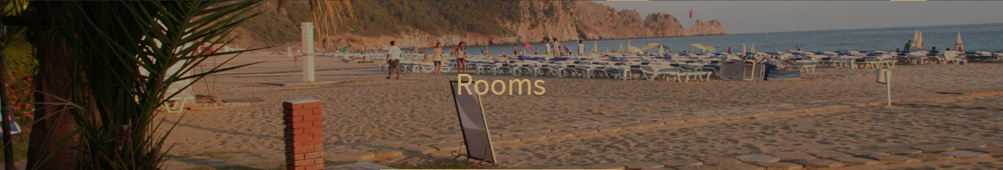

60 Rooms and 120 Beds, situated within walking distance of Alanya’s places of interest

The Rooms are nicely furnished and well equipped with Air-conditioner, TV, Mini Bar ,Music (over the TV), Hair Dryer and safe box. Electricity : AC 220 V.

**Guest Room Amenities**:

* Individually controlled air conditioning
* Private bath and shower.
* Radio (over the TV)
* Remote control satellite TV with national and international channels
* International direct dial telephone
* Personal safe box in room
* Mini refreshment bar
* Hairdryer
* Toiletries(Shampoo, soup ..)Suit, skirt hangers
* Balcony
* Electricity : AC 220 V

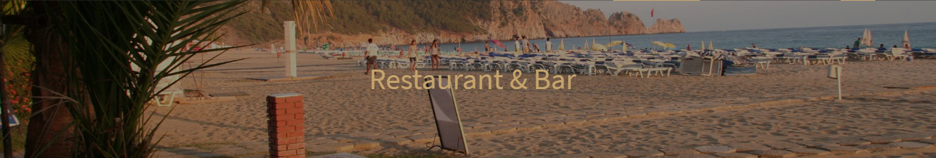

Restaurant

An open buffet service is given by this restaurant for the breakfast and dinner with the Sea and Garden landscape. half board, includes breakfast (buffet) and dinner (buffet) All drinks after breakfast are chargeable.

Hours  
Breakfast 07:30 – 10:00  
Ala Carte Restaurant 12:00 – 16:30  
Dinner 19:00 – 21:00

Snack Bar

You may choose from a selection of delights from the snack bar menu. Traditional Turkish cuisine, Mediterranean foods and soft drinks, cocktails.

PATISERIE

The point of the coffee and tea lovers.

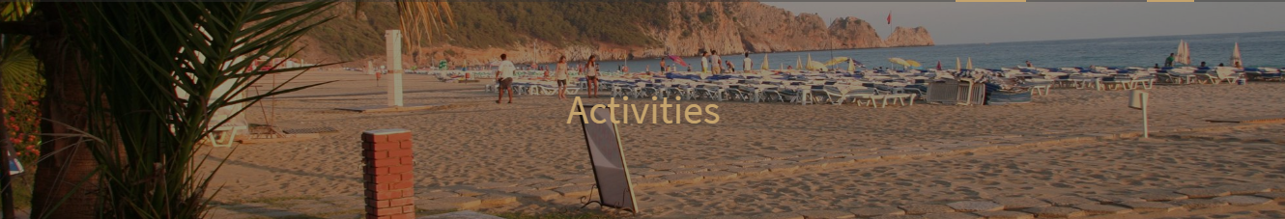

Hotel Facilities now include, following rennovations in the year 2018

Sauna, Turkish Bath, TV Room, Massage Room, Billiards, Game Room and a Fitness Saloon. Mini Market and Hair Dresser are also at the service of our guests.